Creating a Custom Web Interface with ARS
The Web Interface that comes pre-built in ActiveRoles Server is generally suitable for performing most administrative tasks and each are customizable as well to modify the general look, feel, and content within the Web Interface framework provided by Dell. Light modification of the built in default sites is generally fine, but what happens if you need to create a custom portal to provide a specific set of menus, commands, etc… you typically do not want to heavily modify the default pages because sometimes that renders them unusable for normal administrators.
The answer to this is to create a custom web site for ActiveRoles Server Web Interface. Creating a custom site will allow you to base the new site off of one of the default sites as a template and then you may completely customize this site without affecting the default sites.
Below are the steps to add/create a custom site for ActiveRoles Server:
- Login to one of the web servers that is hosting the ARS Web Interface
- Launch the Web Interface Sites Configuration Wizard from the Quest Software folder in the Start Menu
- Click Next on the Welcome Screen
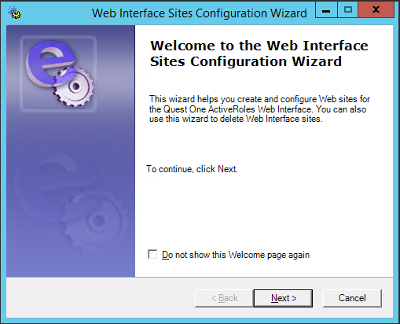
- On the Web Interface Sites page, you will see existing sites on this server, click New to create a new site.
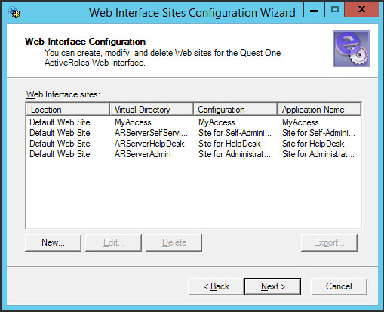
- This dialog in the wizard is where you will name your new custom site and tell the software how to configure it. For my example, I named it CustomPortal and I will be using the Default Site for Administrators as the template for my new site. As you see on the dialog, you can use a template, connect to an existing configuration, or import one from a file (this would be used if you exported a configuration from another server). Click OK when Finished.
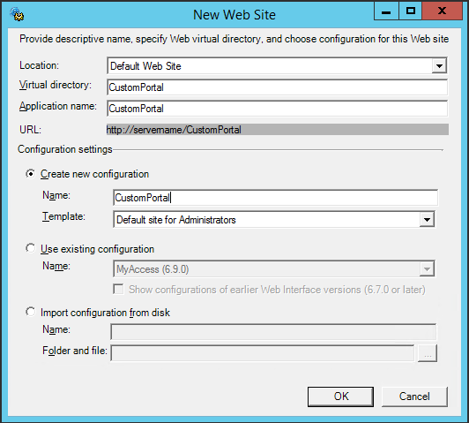
- When you return back to the Web Interface Sites dialog, you will see your new site in the list. Click Next.
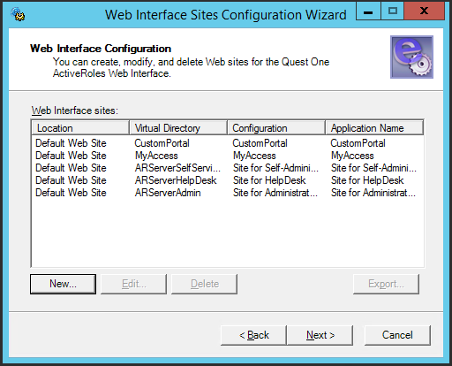
- Click Next to begin the configuration process.
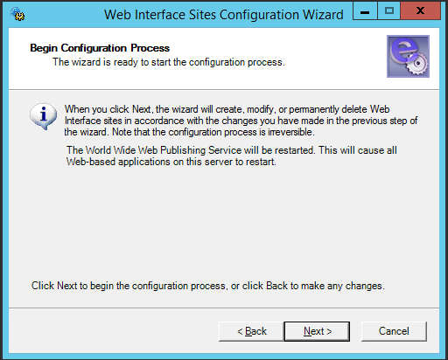
- During the progress of the Wizard, you can see that it has stopped the World Wide Publishing Service and is creating my new CustomPortal site.
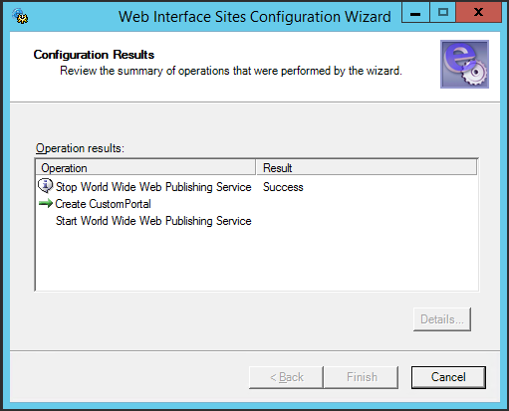
- Click Finish when the configuration is complete.
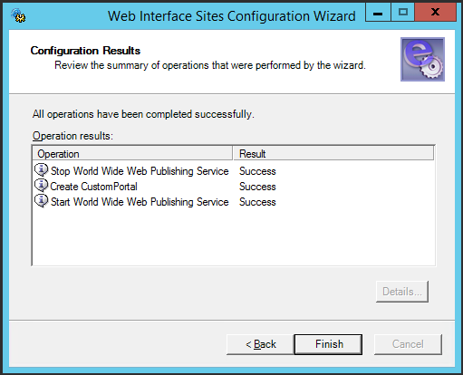

Now there is a new web site on this server called CustomPortal and the configuration for this site has been stored within ARS. What about multiple web servers you say? Well, the answer is simple. Attach to each web server that has the ARS Web Interface software installed on and is a web server you wish to actively serve this new site. Launch the Web Interface Sites Configuration Wizard and follow the procedures for creating a new site as outlined above in steps 1-4.
At step 5, enter the same name for the Virtual Directory and Application exactly as you named them when you created the new site on the original web server, in my case, it is CustomPortal. Then, instead of selecting ‘Create new configuration’, select ‘Use existing configuration’ and select your original configuration name from the drop down list. Click OK when finished.
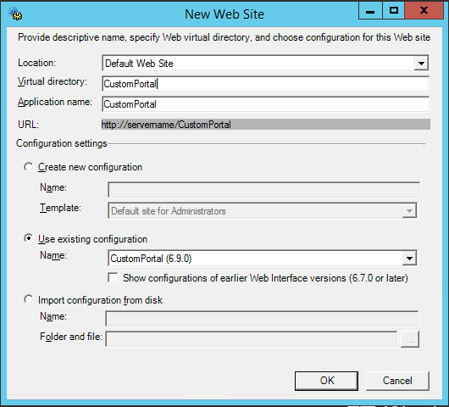
After this, the steps are identical to the new configuration steps 6-9 above.
At this point, you may now connect to your new web site, as you can see in the image below, I have connected to my ARS web server using my new CustomPortal site. Once you are able to login to the web site, since this one is independent of the default site, it may be heavily customized without impacting any other ARS site on the web server.
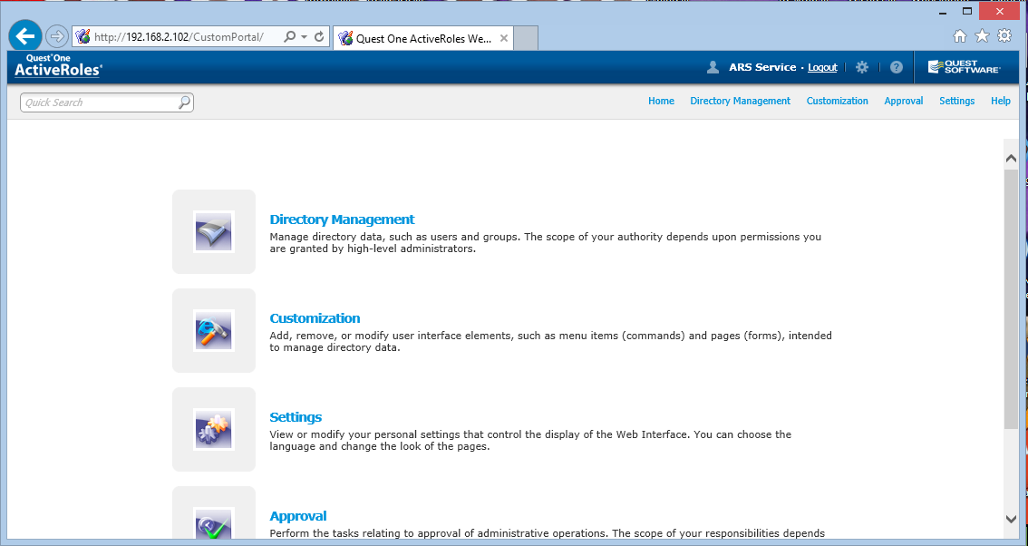

Russ Burden, Jr. Technical Architect LeadThem Consulting

